# 

# 

# 

# 

# **Magento 2 For Tobacco**

# **Connector for Magento v2.2 to 2.4 Module Version: 1.0**

# **Table of Contents**

**Magento 2 For Tobacco** 0

**Connector for Magento v2.2 to 2.4 Module Version: 1.0** 0

**Table of Contents** 1

**Home:** 2

**License** 2

**Getting Started:** 2

**Support** 2

**Prerequisites** 2

**Supported Magento Versions** 2

**Installation** 3

**Install via Composer** 3

**Configuration** 3

**Release Notes** 3

**Extension Features** 3

**Uninstall Extension** 4

**Excise Sales Tax:** 4

**Overview** 4

**Configuration** 4

**Product Attributes** 6

**Tax Breakup** 7

**AvaTax Queue** 7

**AvaTax Logging** 7

**Magento Order and Invoice Numbers** 7

**Overview** 8

**Configuration** 8

**Frontend Checkout** 10

**Frontend Add/Edit Customer Address** 13

**Backend Add/Edit Customer Address** 14

**Backend Order Creation** 15

**Support** 15

# 

# **Home:**

## **License**

This project is licensed under the Open Software License 3.0 (OSL-3.0). See included LICENSE file for full text of OSL-3.0

# **Getting Started:**

## **Support**

For support with your AvaTax account, please visit [avalara.com/technical-support](http://www.avalara.com/Technical-Support). This software will not work unless you have a valid Excise and Avatax account. To obtain the required account information, please contact your Avalara representative.

## **Prerequisites**

* Active Excise account with a company setup.
* Active Avatax account with a company setup.
* Magento running on a server that has the following:
  + Uninstall avalara/avatax-magento extension, if exists.
  + Properly configured CRON job
  + PHP CURL extensions (required by the AvaTax/Excise library)

## **Supported Magento Versions**

supported Magento editions/versions.

* Magento 2.4.0 - 2.4.2 (as of Avalara_Excise 1.0.0)
  + ✅ Open Source (Community)
  + ✅ Commerce (Enterprise)
  + ✅ Commerce Cloud
* Magento 2.3.x (as of Avalara_Excise 1.0.0)
  + ✅ Open Source (Community)
  + ✅ Commerce (Enterprise)
  + ✅ Commerce Cloud
* Magento 2.2.x (as of Avalara_Excise 1.0.0)
  + ✅ Open Source (Community)
  + ✅ Commerce (Enterprise)
  + ✅ Commerce Cloud

### 

## **Installation**

#### **Install via Composer**

This is the recommended installation method as it allows you to easily update the extension in the future. **Important**: Installation must be performed by an experienced Magento developer and these instructions assume that is the case. Installation support can only be provided to developers.

Require the desired version of Avalara Excise/Avatax. Latest version can be installed by running following command:

1. **composer require avalara/excise**
2. Setup the AvaTax module in magento  
   **bin/magento module:enable --clear-static-content Avalara_Excise bin/magento setup:upgrade**
3. **bin/magento cache:flush**
4. If you are deploying the extension to a production environment, follow the [devdocs.magento.com deployment instructions](http://devdocs.magento.com/guides/v2.0/howdoi/deploy/deploy-to-prod.html#deploy-prod)

## **Configuration**

1. To configure the extension, go to **Stores > Settings > Configuration > Sales > Tax.**
2. Details on configuring each of the extension features:

* Avatax Excise - General
* Avatax - Address Validation

1. In the Magento admin, go to **Stores > Settings > Configuration > Sales > Shipping Settings.** Click on the **Origin** section. Enter the address that will be used as the origin or **Shipped From** location in Avalara's Excise tax calculation. **It is *required*** that you specify a postal code in the origin address, no matter what country is specified. Otherwise, you will get errors in checkout and when saving customers.

## **Release Notes**

#### **Extension Features**

* Excise tax calculation.
* Sales tax calculation.
* Shipping and billing address validation.
* Submitting invoice and credit memo transactions to Avatax.
* Application logger for troubleshooting

## **Uninstall Extension**

1. Run this command in the root of your Magento installation directory:   
   **bin/magento module:uninstall Avalara_Excise**
2. If you installed the module using Composer, run these commands in the root of your Magento installation directory: **composer remove avalara/excise**

If you installed the module by copying files, run these commands in the root of your Magento installation directory: **rm -rf app/code/Avalara/Excise**

1. Run the following queries in your Magento database:  
   **-- Remove Excise tables (these tables will be in the sales database in split-database mode) DROP TABLE `excise_queue`;**
2. **DROP TABLE `excise_log`;**

# **Excise Sales Tax:**

## **Overview**

Tax calculation typically happens during checkout process like shopping cart, checkout. This extension allows Magento to calculate excise tax and sales tax, additionally provides an address validation feature. Extension will calculate tax as soon as customers enter postal code either on the Estimate Shipping and Tax section on shopping cart or Shipping Address form during the checkout process. Tax will be calculated by calling Excise API. The API will identify the products based on the product configuration and will calculate the applicable excise or sales tax.

To use excise API for tax calculation, make sure you set Product Custom attributes values.

A cronjob task runs every five minutes to send invoices and credit memos to Avalara Excise. The status of each pending item can be found in the AvaTax Queue in **Stores > AvaTax Queue.** The Magento CRON must be configured for the extension to work properly.

## **Configuration**

1. In the Magento admin, go to **Stores > Settings > Configuration > Sales > Tax.** Click on the Avatax Excise - General section.
2. Review each of the options in this section and input the appropriate value.

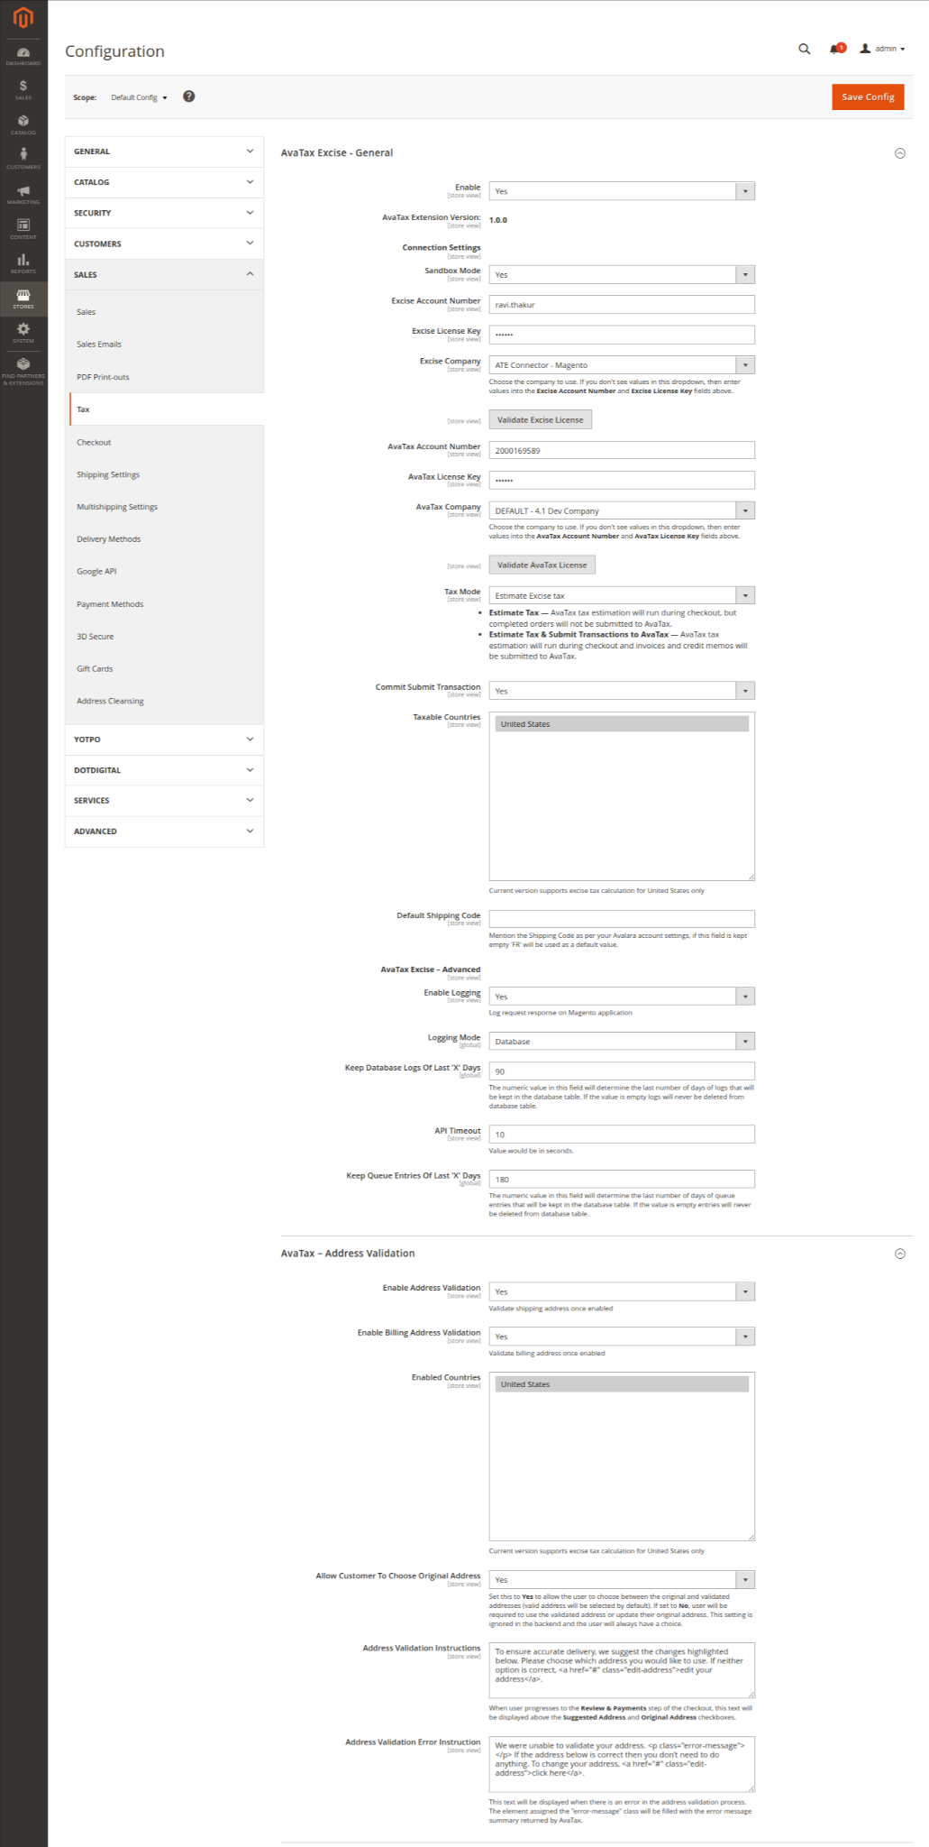

1. The comment text underneath each of the options in this section should explain the purpose of the setting.

## **Product Attributes**

Custom product attributes are defined on **Catalog > Products.** Custom attributes are defined under "Excise Attributes" tab.

**Excise Product Code** - This value is tax class configured in Avatax. If this is set as none then product SKU will be sent instead in the API call.

**Unit Of Measure** - The Measurement type, the measure value in which the product is defined.

**Unit Quantity Unit Of Measure** - Product unit quantity of measure.

**Unit Volume Unit Of Measure** - Product volume unit of measure.

**Purchase Unit Price** - The purchase price per unit.

**Purchase Line Amount** - The purchase line amount.

**Unit Quantity** - Product unit quantity.

**Alternative Product Content** - This field is required for products having alternate fuel content.

**Unit Volume** - Volume of a unit.

## **Tax Breakup**

The module will provide the tax break up on the order, invoice and credit memo detail page in the Magento backend. This will enable the administrator to see the components that are part of the tax. The tax will be broken down into 'sales tax', 'excise tax' and 'shipping tax' components. The breakup will also be available on the line-item level to see the tax per item in the order, invoice and credit memo.

The breakup will also be available in the order, invoice and credit memo listing pages in the Magento backend which can be downloaded as a report. This will enable the administrator to have the information for reporting and reconciliation of transactions.

## **AvaTax Queue**

The AvaTax Queue functionality only works when **Tax Mode** is set to **Estimate Tax & Submit Transactions to AvaTax.** The following section assumes that AvaTax queueing is enabled. To view the AvaTax Queue, in the Magento admin, go to **Stores > AvaTax Queue.**

When invoices and credit memos are created in Magento, new records are added to the AvaTax Queue with a **pending** status. If a CRON job is properly configured, then every 5 minutes, all pending records will be submitted to AvaTax with a **Document Type** of **Sales Invoice** or **Return Invoice**, depending on whether the record is a Magento invoice or credit memo (respectively). If there are errors submitting the record, Magento will attempt to resend the record for the number of times configured in the **Max Queue Retry Attempts** constant property, this is set for maximum 3 attempts.

If you are in a development or staging environment and do not have a CRON job setup, or you want to send invoice and credit memo records individually you can manually send these records to AvaTax using the **Post to AvaTax** button on the invoice and credit memo details page in the Magento admin.

## **AvaTax Logging**

The logging functionality built into this extension is for debugging purposes. If you are experiencing issues with this extension, you can review the logs to see if they provide any details about the issues you are experiencing.

This extension can log information in two locations: In files (in the var/log/ directory) and/or in the database (in **Stores > AvaTax Logs**), depending on the logging settings you have configured in **Stores > Settings > Configuration > Sales > Tax > AvaTax Settings > Logging Settings.**

## **Magento Order and Invoice Numbers**

If you are using AvaTax with a **Tax Mode** of **Estimate Tax & Submit Transactions to AvaTax**, when Invoices or Credit Memos get sent to AvaTax, the Invoice/Credit Memo 'id' will be sent in the **InvoiceNumber** field prefixed with ‘INV’ or ‘CM’ for invoice and credit memo, respectively. The Magento Order Number will be sent in the **CustomString** field.

**Address Validation:**

## **Overview**

This extension implements address validation in nearly every area where an address can be entered:

* Frontend Checkout
* Frontend add/edit customer address
* Backend order creation
* Backend add/edit customer address

The following sections explain how address validation works in the four areas listed above. Note: Address validation is not enabled for virtual orders (orders where only a billing address is required).

## **Configuration**

1. In the Magento admin, go to **Stores > Settings > Configuration > Sales > Tax.** Click on the **AvaTax - Address Validation** section.
2. Review each of the options in this section and input the appropriate value.



## **Frontend Checkout**

When a guest or a signed in customer proceeds from the **Shipping** step to the **Review & Payment** step, the address they submitted will be sent to AvaTax to be validated.

If the configuration setting **Allow User To Choose Original (Invalid) Address** has been set to **Yes**, both the Suggested Address and Original Address will be displayed:

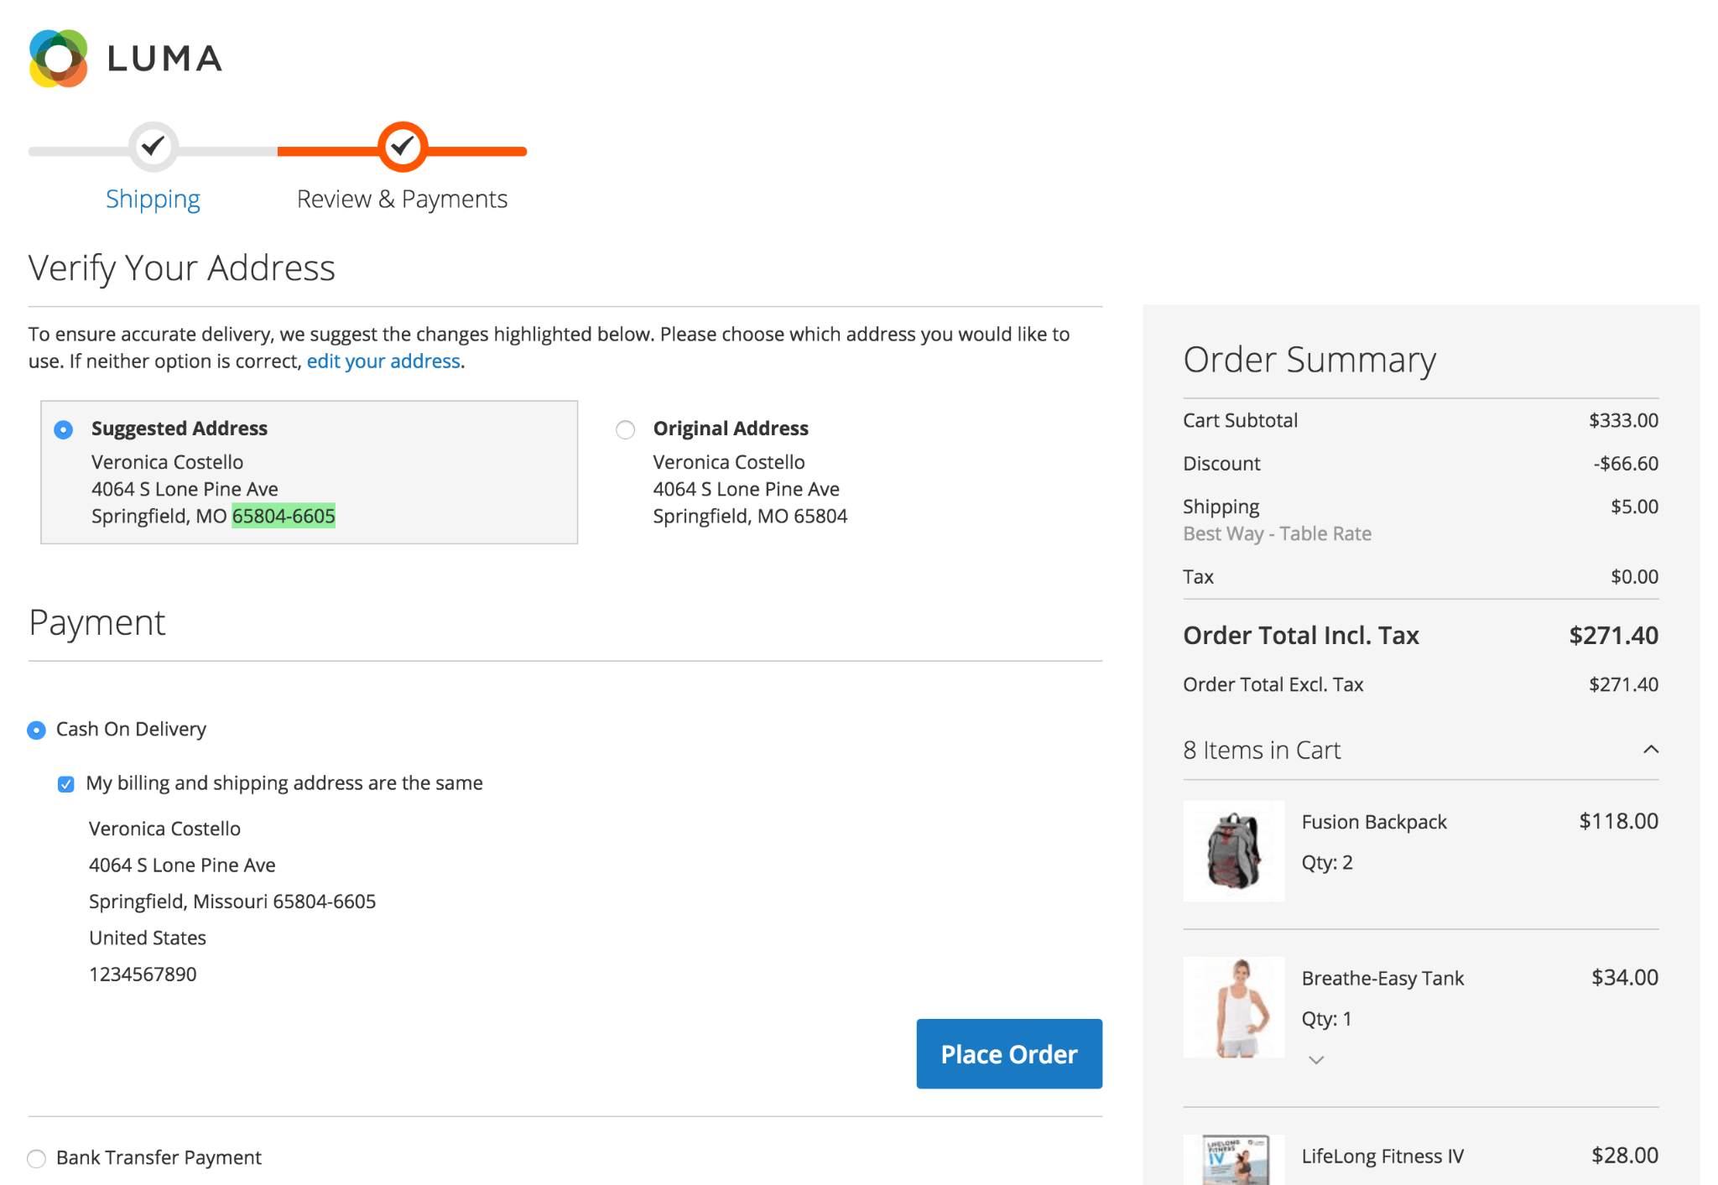

If the configuration setting **Allow User To Choose Original (Invalid) Address** has been set to **No**, only the valid address will be displayed to the user:

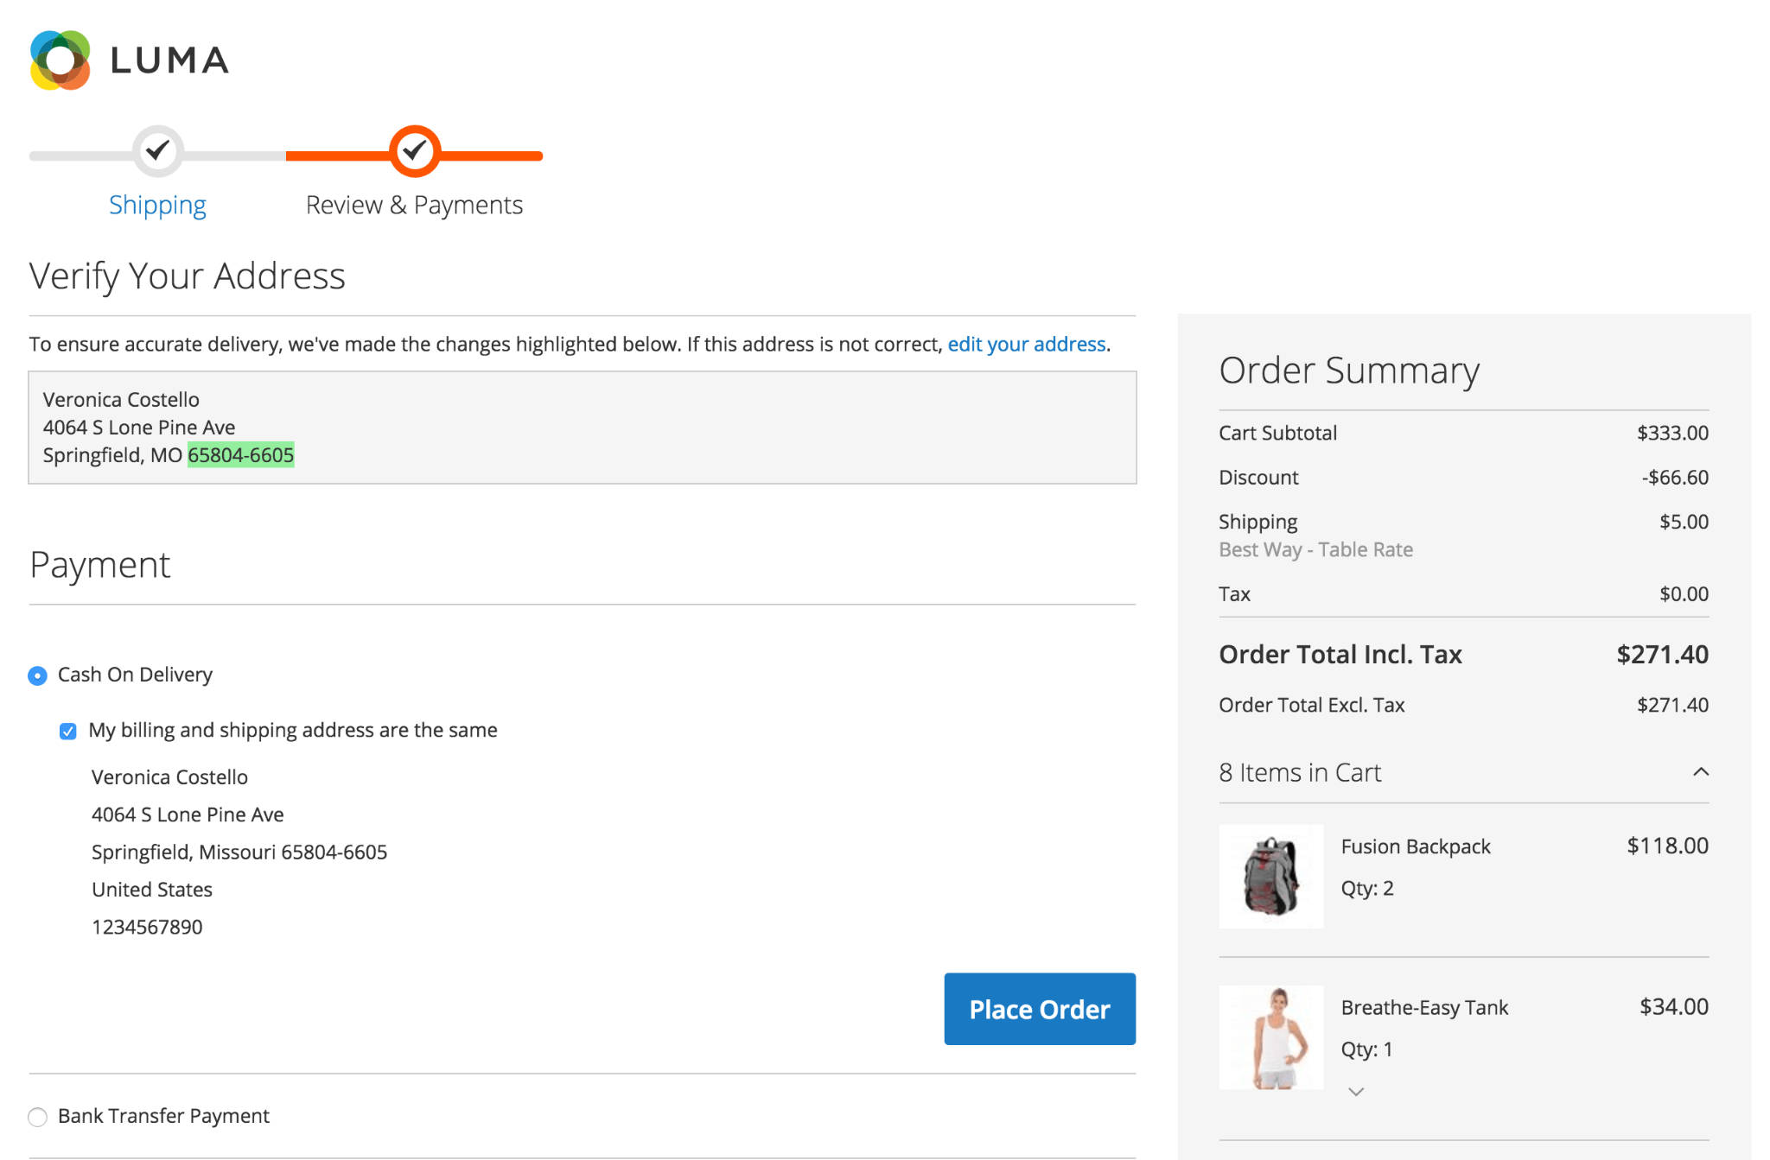

If a signed in customer is checking out and their address gets validated, the address the customer selected will automatically be set to the suggested address once the customer proceeds to the **Review & Payment** step. If the customer selects the original address, their customer address will be updated to that address. This will happen every time the user selects a different address.

If the user submits an address that AvaTax cannot validate, an [error message](https://help.avalara.com/kb/001/Common_Error_Messages_returned_with_GetTax_and_Validate_Requests#Common_Error_Messages) will be displayed to give some indication to the user that their address may be incorrect. This does not disrupt the checkout process:

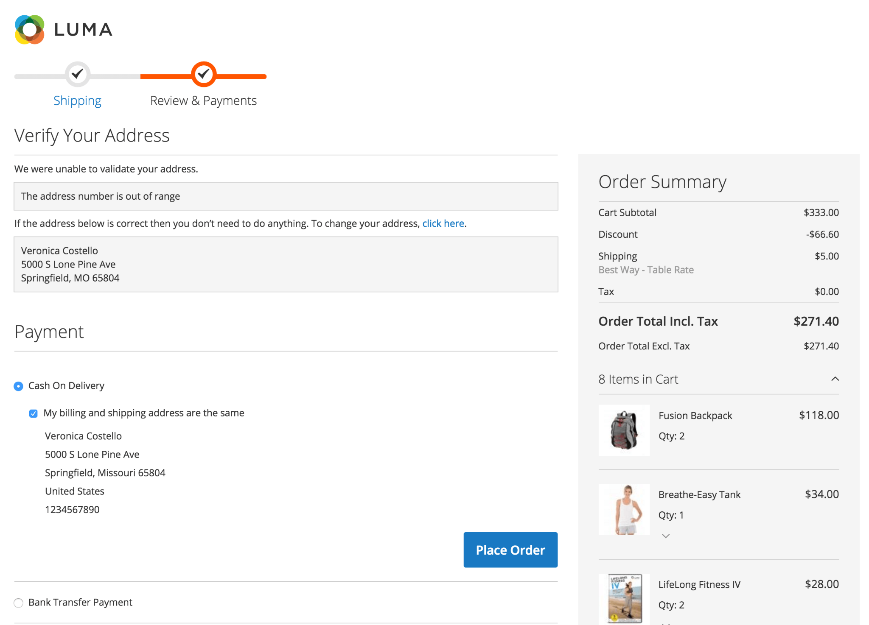

If the address is already valid or if the address is from a country that is not on the list of **Enabled Countries** for address validation, nothing will be displayed to the user.

If the user clicks the **edit your address** or **click here** links in the instructions, they will be navigated back to the **Shipping** step.

## **Frontend Add/Edit Customer Address**

When a customer is adding or editing an address tries to save that address, they will be presented with a modal displaying this **Verify Your Address** form:

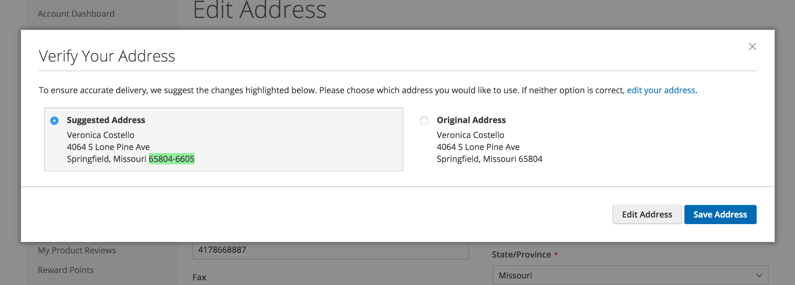

If the customer clicks the **x** icon, the **edit your address** link, or the **Edit Address** button, the modal will close and the form will not be submitted. If the customer clicks **Save Address** with the suggested address selected, the fields which are highlighted will be updated in the form and the form will be submitted. Otherwise, the original address will be submitted without any modifications to the form fields. If the config field **Allow User To Choose Original (Invalid) Address** is set to **No**, and the customer clicks save address, the valid address will be submitted. If the API response returns an error, that error will be displayed to the customer just as it is in the checkout. The customer will then have the option of either editing their address or saving it. If the address is not located inside one of the enabled countries or is already valid, nothing will be displayed to the user and the form will be submitted normally.

## 

## **Backend Add/Edit Customer Address**

Address validation in this area is triggered by clicking the Validate Address button at the bottom of an address form:

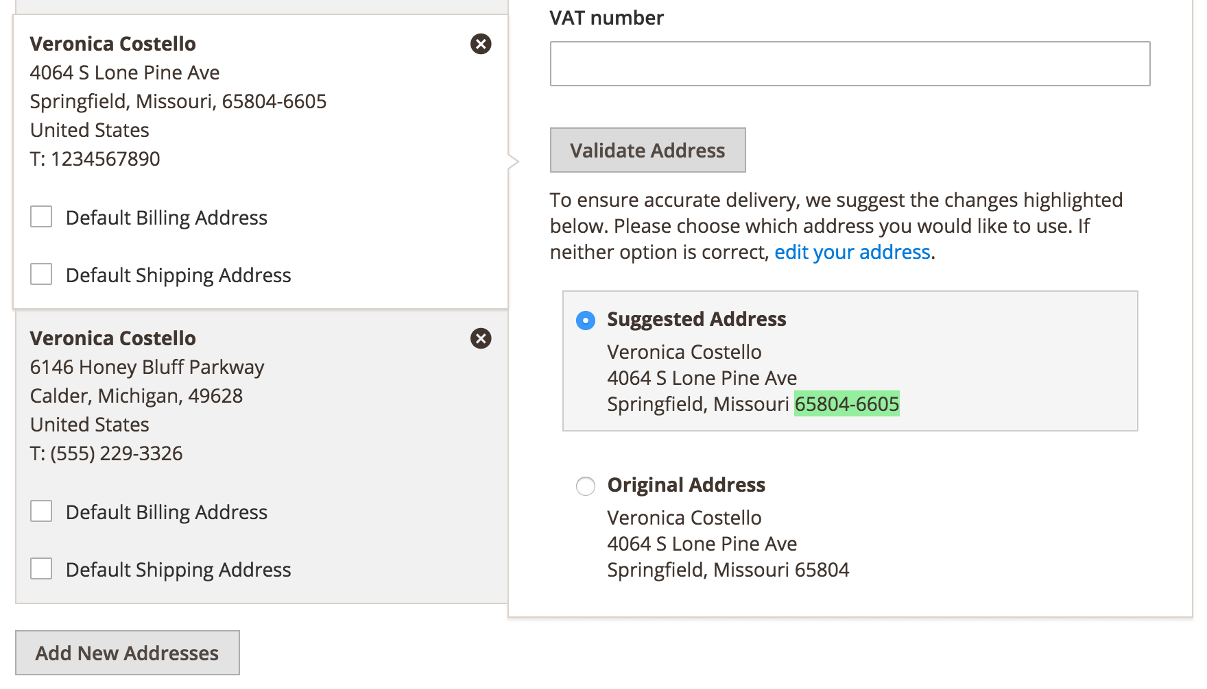

If the address is already valid, a success message will appear displaying the message *"This address is already valid"*. If the address is not from one of the enabled countries, an error message will appear displaying the message *"Address validation is not enabled for the country you selected"*. After the address has been validated, the suggested address will automatically be selected and the form will be updated. Selecting either address will update the form with that address. Clicking the **edit your address** link will scroll to the top of the page.

If the address is unable to be validated (see screenshot below), a message will be displayed indicating the reason why the validation failed (e.g. *"An exact street name match could not be found"* or *"The address number is out of range"*). The customer address can be revised by clicking the provided link; saving the customer record at this point will save the address as entered.

## **Backend Order Creation**

Address validation in this area is also triggered by clicking the **Validate Address** button of the bottom of the Billing or Shipping Address forms. If **Same As Billing Address** is checked, the **Validate Address** button will not exist below the Shipping Address form. After the Validate Address button is clicked, a modal will appear displaying the same form that is displayed in the frontend add/edit customer address area:

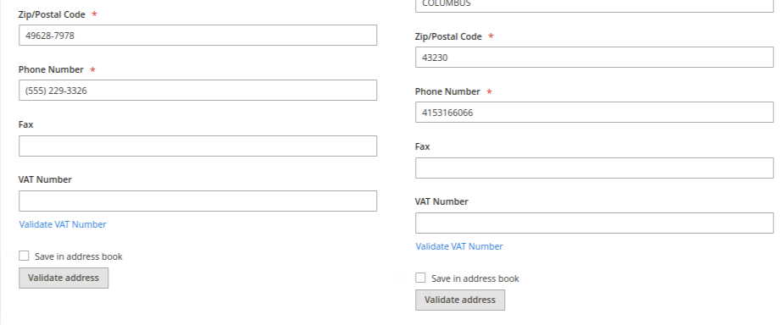

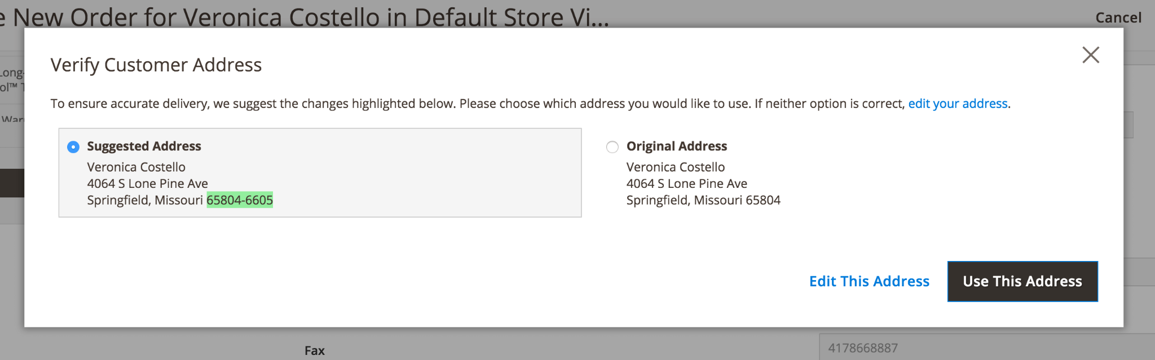

If the address is already valid, a success message will appear displaying the message *"This address is already valid"*. If the address is not from one of the enabled countries, an error message will appear displaying the message *"Address validation is not enabled for the country you selected"*.

## **Support**

Contact Avalara for any support requests, either via [support@avalara.com](mailto:support@avalara.com) or via [this page](https://salestax.avalara.com/contact-us/).

*END OF DOCUMENT*